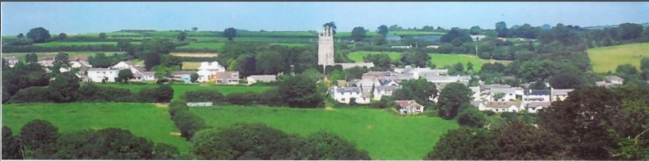
25th October 2025
Dear Councillor,
You are summoned to attend a meeting of North Hill Parish Council on Monday 3rd November 2025 at 7.30pm in the Village Hall.
Please find attached the agenda for our meeting. We ask that if any member of the public has issues, they would like to raise that they contact the clerk prior to the meeting so that we can best manage them.
Please remember that the time allotted for Matters of Community Concern is not a forum to discuss what has taken place during this meeting and that any matter raised here would likely be added to the NEXT meeting agenda for discussion.
Yours faithfully,
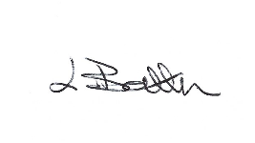
Lena Batten, Clerk to the Council
Members of the public are welcome to attend the meeting. However, we would like those attending to register prior to the meeting by emailing the Parish Clerk. Email: clerk@northhillparish.org.uk
AGENDA
- TO RECEIVE APOLOGIES:
- CODE OF CONDUCT : a) TO RECEIVE DECLARATIONS b) TO GRANT DISPENSATIONS:
3. PUBLIC COMMENTS ON ITEMS ON THE AGENDA ONLY:
4. TO RECEIVE AND APPROVE THE MINUTES OF THE 6th OCTOBER 2025 FULL COUNCIL MEETING:
5. ANY MATTERS ARISING FROM PAST MINUTES NOT ON THE CURRENT AGENDA:
6. TO CONSIDER PLANNING APPLICATIONS RECEIVED FROM CORNWALL COUNCIL BY DATE OF THIS MEETING:
6.1 To note for information - PA25/04903 - 1 Church View, Glubhole Lane, North Hil, PL15 7PQ - Proposal Listed
building consent for the replacement of windows, along with replacing the timber fascia board, and repair
the porch over the front door to the street facing elevation of the property – Approved.
6.2 To note for information – PA25/05398 – Lanoy farmhouse, Lanoy Road, Coads Green, PL15 7LU – Conversion of barn to annex and / or holiday unit – Approved.
6.3 To note for information – PA25/07912 Land to the South of Coad's Green and to the west of the B3257 - Prior notification of agricultural or forestry development for: The construction of an agricultural general purpose building.
6.4 To note for information - PA25/05890 - Lynher Cottage, Middlewood, North Hill, PL15 7NN - Proposal Proposed first-floor extension (revised scheme to that approved under PA19/00288) – approved.
7. ANY APPLICATIONS RECEIVED BEFORE THE DATE OF THIS MEETING: None.
8. TO REVIEW CORRESPONDENCE AND TO AGREED RESPONSES REQUIRED:
8.1 To consider / resolve quotes for the purchase of a new notice board at Congdon’s Shop.
8.2 To note for information all Councillors have signed the Civility and Respect Statement of Assurance.
8.3 To consider / resolve any training opportunities available that Councillors would like to attend.
8.4 To note for information the clerk requested further details regarding the defib in North Hill and has been
informed that a new battery is likely to be needed in November 2026 at an approximate cost of £318.00.
8.5 To consider / resolve whether to comment on “Understanding Cornish Places”.
8.6 To consider / resolve whether to submit the survey on the application for Cornwall to become an Age Friendly
Community.
8.7 To receive information from one member of the public in relation to the 20mph roll out being extended
further up the road and consider any response required.
8.8 To receive any update on the draft Emergency Plan.
8.9 To consider / discuss the pot hole in the car park as requested by one Councillor.
8.10 To consider / resolve if any Councillors want to attend the Cornwall Local Plan session due to take place on
the 18th November 2025 at Callington Cricket Club.
8.11 To accept the quotes received and resolve whether to proceed with the replacement shackles in the play area.
9. TO REVIEW DETAILS FOR NORTH HILL PARISH COUNCIL CEMETERY:
The granite posts are ready, just awaiting the Crookes being fitted and then they will be delivered.
10. APPROVAL OF THE LIST OF PAYMENTS / RECEIPTS FOR OCTOBER 2025 & TO RECEIVE 30TH OCTOBER 2025
BANK STATEMENT:
10.1 AUTHORISATION OF EXPENSES INCLUDING SALARY:
i) £18.00 (PAYE G. Pollard payroll October, dd)
ii) £702.92 (Lena Batten, October Salary)
iii) £150.07 (Lena Batten, October NI and tax)
iv) £43.64 (room rent)
v) £153.82 (Glasdon, purchase of dog poo bin)
vi) £194.39 (TEEC, annual website hosting)
vii) £42.00 (Cornwall ALC Ltd, planning training)
viii) £45.00 (NHVH, Room rent, July / Aug / Sept)
ix) £20.00 (Lena Batten, signage)
x) £113.94 (defibrillation Electrodes)
10.2 RECEIPTS:
i) £5358.49 (CIL payment)
ii) £318.33 (VAT reimbursement)
10..3 To receive bank statement:
Bank Statement as of 30th October 2025 £21,901.12.
11. TO REVIEW MONTHLY BUDGET RECONCILIATIONS:
11.1 Budget Sheet Attached.
11.2 To set the budget for the next financial year 2026-2027 and agree the precept amount for submission:
11.3 To review / update North Hill Parish Council’s Risk Assessment and Management Procedures.
11.4 To review / update North Hill Parish Council’s Asset register.
12. To agree the advert for grant applications to be distributed with applications being heard at the December 1st 2025 meeting and review grant policy:
12. TO REVIEW MONTHLY RAG: (Red, Amber, Green)
12.1 RAG Sheet attached.
13. REPORT FROM CORNWALL COUNCIL WARD MEMBER COUNCILLOR PARSONS:
14. ITEMS FOR INCLUSION AT THE NEXT MEETING:
15. DATE & TIME OF NEXT MEETING:
16. CLOSE OF BUSINESS:

